**Dependency-on**

If one bean has a dependency on another bean called as depends-on concepts.

**Why?**

If class A is depends on B, class B depends on class c then we should go for dependency on concepts.

Note- Mutual dependency is not allowed here as shown in below fig as-

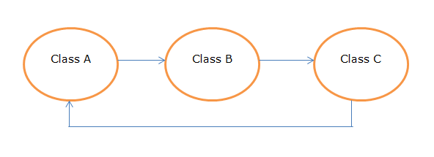Program-

**A.java**

**package** com.test;

**public** **class** A {

**public** A() {

System.***out***.println("A object");

}

}

**B.java**

**package** com.test;

**public** **class** B {

**public** B() {

System.***out***.println("B object");

}

}

**C.java**

**package** com.test;

**public** **class** C {

**public** C() {

System.***out***.println("C object");

}

}

**Spring.xml**

<?xml version=*"1.0"* encoding=*"UTF-8"*?>

<beans xmlns=*"http://www.springframework.org/schema/beans"*

xmlns:xsi=*"http://www.w3.org/2001/XMLSchema-instance"*

xsi:schemaLocation=*"http://www.springframework.org/schema/beans*

*http://www.springframework.org/schema/beans/spring-beans-2.5.xsd"*>

<bean id=*"a"* class=*"com.demo.A"* depends-on=*"b"*></bean>

<bean id=*"b"* class=*"com.demo.B"* depends-on=*"c"*></bean>

<bean id=*"c"* class=*"com.demo.C"*></bean>

</beans>

**Test.java**

**package** com.test;

**import** org.springframework.context.ApplicationContext;

**import** org.springframework.context.support.ClassPathXmlApplicationContext;

**public** **class** Test {

**public** **static** **void** main(String[] args) {

ApplicationContext ap=**new** ClassPathXmlApplicationContext("spring.xml");

}

}

**Pom.xml**

<project xmlns=*"http://maven.apache.org/POM/4.0.0"*

xmlns:xsi=*"http://www.w3.org/2001/XMLSchema-instance"*

xsi:schemaLocation=*"http://maven.apache.org/POM/4.0.0 http://maven.apache.org/xsd/maven-4.0.0.xsd"*>

<modelVersion>4.0.0</modelVersion>

<groupId>spring</groupId>

<artifactId>SpringDemo</artifactId>

<version>0.0.1-SNAPSHOT</version>

<dependencies>

<dependency>

<groupId>org.springframework</groupId>

<artifactId>spring-core</artifactId>

<version>${spring.version}</version>

</dependency>

<dependency>

<groupId>org.springframework</groupId>

<artifactId>spring-context</artifactId>

<version>${spring.version}</version>

</dependency>

</dependencies>

<properties>

<spring.version>3.2.3.RELEASE</spring.version>

</properties>

</project>

**Output-**

A object

C object

B object